**Section 3**

**Problem1**

Delete 42,70,30

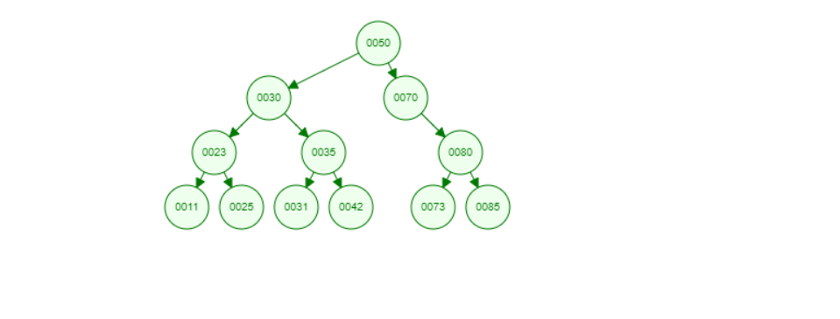

Answer :42 is a branch so we can delete it directly

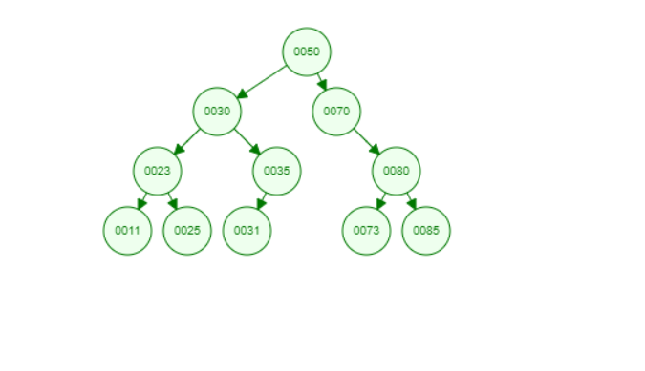

Answer: 70 has one branch (Parent, Child) so we can delete it and connect the child with the parent

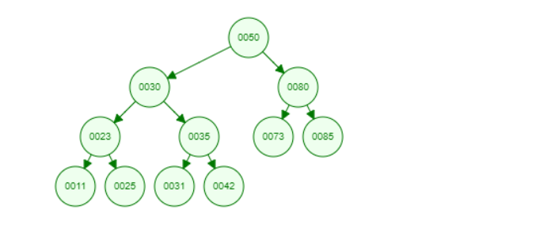

Answer :30 has two child so we can delete it and choose the max value in the left branch so we can choose 25

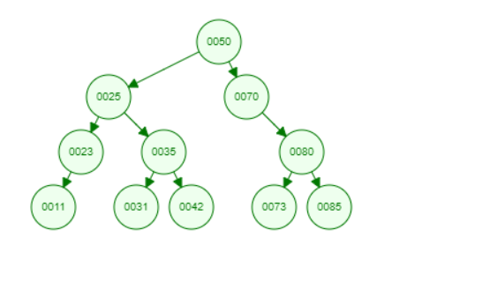

Problem 3